*Assignment 3 - 4*

*Instructor: Faisal Khan*

|  |  |  |
| --- | --- | --- |
| *Name* | *Student ID* | *Group#* |
| Alexander Gutierrez | c0895239 | 1 |
| Can Zorbey | c0895400 | 1 |
| David Barrios | c0893262 | 1 |
| Paul Jordan Untalan | c0899319 | 1 |

1-Use Documentation Comments where needed.

2-In your project src folder add this word document with all your group members names, having the screen shots of your output with source code after each question.

2-Right Click on your Project Folder in Eclipse, Copy Option is available. Create a copy of the Project and upload the zipped folder using Moodle.

|  |  |
| --- | --- |
| **Assignment 3** | **10** |

Write a program that will ask the user to enter the name and number of Items or quantity of a purchase On a grocery store.

The user is supposed to purchase at lease 5 items.

User should be asked repeatedly to enter the name of Item and quantity or number of items needed until the user selects to exit.

The program should then compute the state and county sales tax on each item.

Your Program should display the Item name ,price ,state sales tax ,country sales tax and Final Price including taxes after each Item purchase.

In the End

The program should display the amount of the total purchase, the state sales tax, the county sales tax, the total sales tax, and the total of the sale (which is the sum of the amount of purchase plus the total sales tax).

Note: For User Input Use Scanner Class or JOptionPane .

**Source Code:**

package com.lcit.assignments;

import javax.swing.JOptionPane;

import java.util.Random;

/**

* This program asks the user to enter the name and number of items of a purchase on a grocery store.

* It starts by asking the user to enter the state to calculate the state taxes accordingly.

* Then it asks for the name of the item and the quantity to be purchased. Data validation is done to ensure

* the state name is enter correctly. The prices of the products are computed using random numbers.

* The output (receipt) is built using the format() method of the String class. The JOptionPane class is used

* to get the input from the user, and the output is displayed on the console.

* @param args */

public class Assignment_3 {

public static void main(String[] args) {

Random randomNumber = new Random();

final String HEADER = " STAR SHOP \n" +

" 347 Lawson Rd \n" +

" Tel: (647)860-1662 \n" +

"****************************************************************************************************\n" +

" RECEIPT \n" +

"****************************************************************************************************\n" +

String.format("%-16s %-7s %-12s %-15s %-15s %-17s %s\n", "Description", "Qty" , "Price c/u", "Price w/o Tax", "State Tax", "Country Tax", "Final Price");

final double COUNTRY_TAX = 0.08;

String itemName,

again = "y",

output = HEADER,

state;

double itemPrice,

itemCountryTax,

itemStateTax,

itemPriceNoTax,

itemFinalPrice,

subtotal = 0,

countryTax,

stateTax = 0.0,

stateTaxTotal,

total;

int quantity,

i = 1;

JOptionPane.showMessageDialog(null, "=-=-=-=-=-=-=-=-=-=-=-=-=-=-=-=-=-=-=\n" +

" This program calculates the total \n" +

" amount of a purchase. \n" +

"=-=-=-=-=-=-=-=-=-=-=-=-=-=-=-=-=-=-=");

while (stateTax == 0) {

state = JOptionPane.showInputDialog("Select your state [press H for help]: ");

switch (state.toUpperCase()) {

case "ON":

stateTax = 0.08;

break;

case "AB": case "BC": case "MB": case "NT":

case "NU": case "QC": case "SK": case "YT":

stateTax = 0.05;

break;

case "NB": case "NL": case "NS": case "PE":

stateTax = 0.07;

break;

case "H":

JOptionPane.showMessageDialog(null, "State Codes:\nAB = Alberta\nBC = British Columbia\nMB = Manitoba\nNT = Northwest Territories\n"+

"NU = Nunavut\nQC = Quebec\nSK = Saskatchewan\nYT = Yukon\nON = Ontario\n" +

"NB = New Brunswick\nNL = Newfoundland and Labrador\nNS = New Scotia\nPE = Prince Edward Island");

continue;

default:

JOptionPane.showMessageDialog(null, "Please insert a valid state code.");

continue;

}

}

do {

itemName = JOptionPane.showInputDialog("Enter the name of the item #" + i + ": ");

quantity = Integer.parseInt(JOptionPane.showInputDialog("How many of this items would you like to purchase?")) ;

itemPrice = Double.parseDouble(String.format("%.2f", randomNumber.nextDouble(50) + 30)) ;

itemCountryTax = (quantity * itemPrice) * COUNTRY_TAX;

itemStateTax = (quantity * itemPrice) * stateTax;

itemPriceNoTax = quantity * itemPrice;

itemFinalPrice = itemCountryTax + itemStateTax + (quantity * itemPrice);

subtotal += itemPriceNoTax;

output += String.format("%-16s %-7d $%-,11.2f $%-,14.2f $%-,14.2f $%-,16.2f $%,.2f\n", itemName, quantity, itemPrice, itemPriceNoTax, itemStateTax, itemCountryTax, itemFinalPrice);

i++;

if (i > 5) {

again = JOptionPane.showInputDialog("Would you like to enter another item? Y/N").toLowerCase();

}

} while(i <= 5 || again.equals("y"));

output += "-----------------------------------------------------------------------------------------------------\n";

output += String.format("%-87s $%.2f\n", "Subtotal", subtotal);

countryTax = subtotal * COUNTRY_TAX;

stateTaxTotal = subtotal * stateTax;

total = subtotal + countryTax + stateTaxTotal;

output += String.format("%-87s $%,.2f\n", String.format("State Tax %.0f%%", stateTax * 100), countryTax);

output += String.format("%-87s $%.2f\n", "Country Tax 8%", stateTaxTotal);

output += "-----------------------------------------------------------------------------------------------------\n";

output += String.format("%-87s $%,.2f\n", "TOTAL", total);

System.out.println(output);

System.exit(0);

}

}

**Output:**

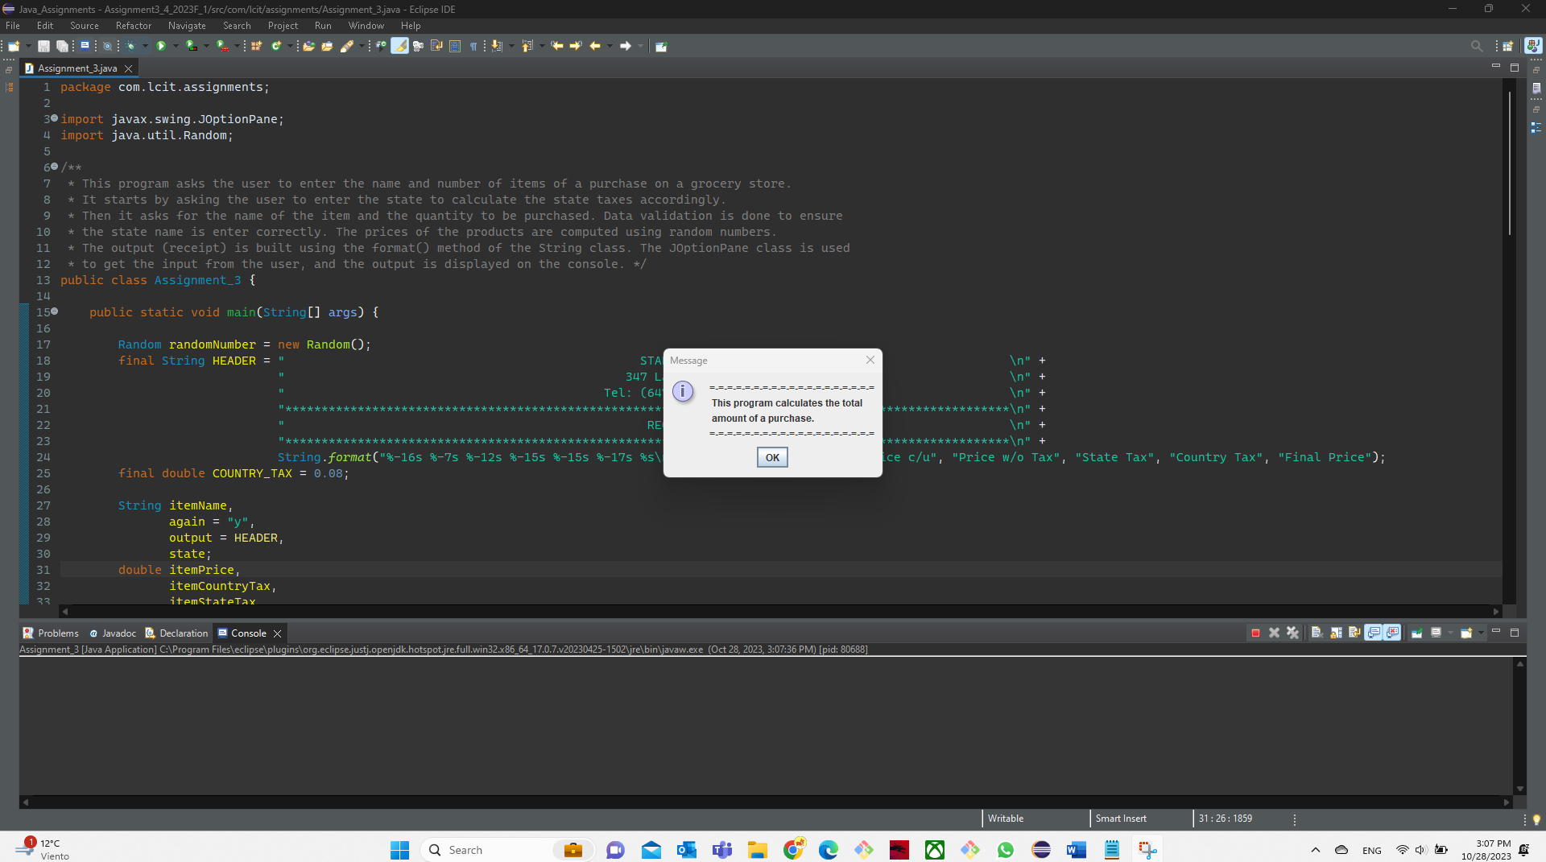

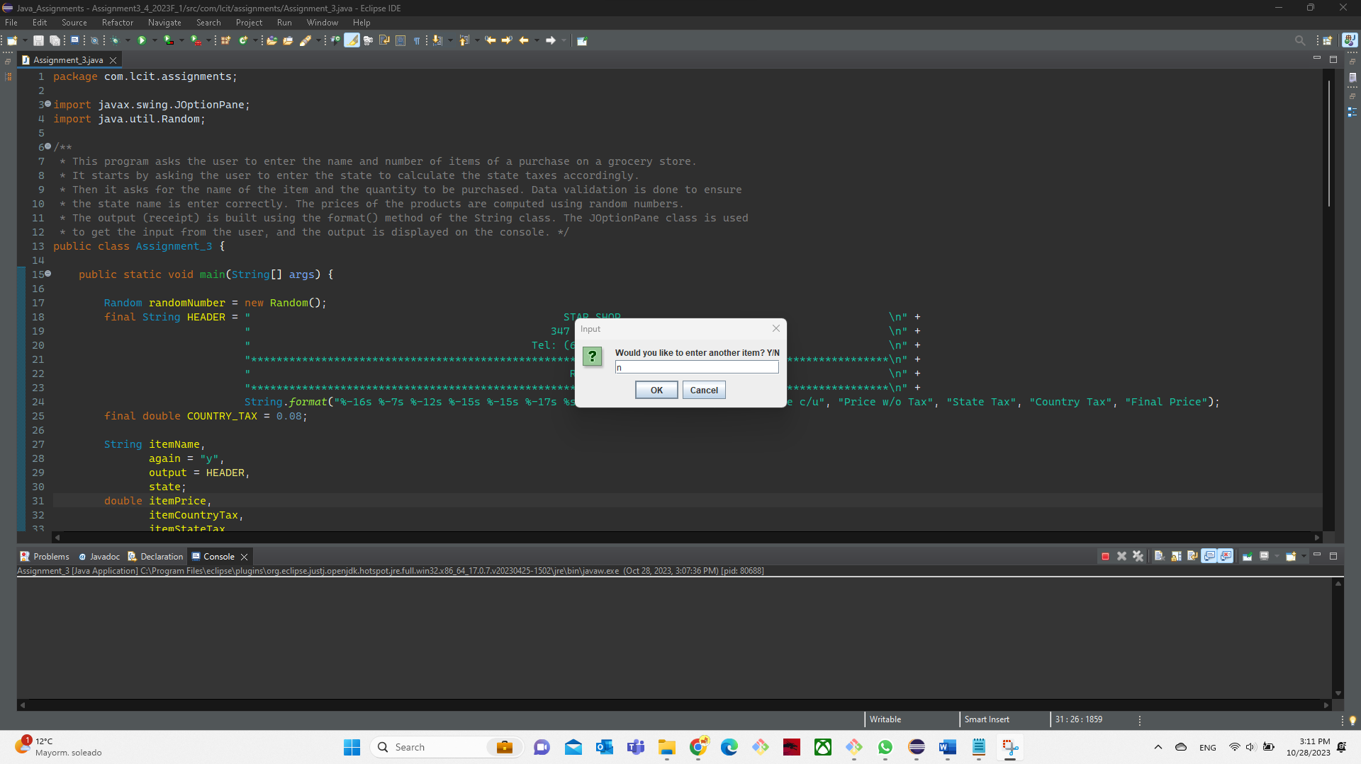

|  |  |
| --- | --- |
| **Assignment 4** | **10** |

The Fast Freight Shipping Company charges the following rates:

Weight of Package Rate per 500 Miles Shipped

* 2 pounds or less $1.10
* Over 2 pounds but not more than 6 pounds $2.20
* Over 6 pounds but not more than 10 pounds $3.70
* Over 10 pounds $3.80

The shipping charges per 500 miles are not prorated. For example, if a 2-pound package is shipped 550 miles, the charges would be $2.20. Write a program that asks the user to enter the weight of a package and then displays the shipping charges.

**Source Code:**

package com.lcit.assignments;

import java.util.Scanner;

public class Assignment_4 {

/**

* This Freight Shipping Calculator will be taking the user's input for their package weight (in pounds or lbs)

* and the distance of the delivery destination (in miles).

*

* Based on the weight of the package a fixed package cost will be designated.

*

* The total cost of the delivery will be determined by a multiplier or increment which is equal to

* the number of times the delivery destination exceeds 500 miles.

*

* As an example, If the package weight is less than 2.00 pounds, the package cost will be $ 1.10.

* If the delivery distance is 501 miles, the increment will be 2 because it already exceeded the 500 mile

* threshold. If the distance was 1001 miles, then the increment will be 3.

*

* @param args

*/

public static void main(String[] args) {

Scanner input = new Scanner(System.in);

System.out.println("Welcome to the Fast Freight Shipping Calculator!");

System.out.print("\nPlease Enter the weight of your package in pounds (lbs): ");

double packageWeight = input.nextDouble();

double packageCost = 0.0;

double deliveryDistance = 0.0; // distance in miles

double deliveryCost = 0.0; // package delivery cost per 500 miles. not pro-rated.

final String OUTPUT_CURRENCY = "%-30s $%.2f\n",

OUTPUT_UNITS = "%-30s %.2f\n";

if (packageWeight > 10.00) {

packageCost = 3.80;

}

else if (packageWeight > 6.00) {

packageCost = 3.70;

}

else if (packageWeight > 2.00) {

packageCost = 2.20;

}

else if (packageWeight <= 2.00 && packageWeight > 0) {

packageCost = 1.10;

}

else {

System.out.println("Error!!!");

System.out.println("Package weight should be more than 0 pounds.");

System.out.println("Please try again.");

}

System.out.print("Please Enter the delivery distance in miles: ");

deliveryDistance = input.nextInt();

if (deliveryDistance > 0) {

deliveryCost = (((int) deliveryDistance / 500) + (deliveryDistance % 500 != 0 ? 1 : 0)) * packageCost; // computes the multiplier if the distance is more than 500 miles.

System.out.println();

System.out.println("-----------------------------------------------------------");

System.out.printf(OUTPUT_UNITS, "Package weight (lbs): ", packageWeight);

System.out.printf(OUTPUT_CURRENCY, "Shipping cost per 500 miles: ", packageCost);

System.out.printf(OUTPUT_UNITS, "Distance (miles):", deliveryDistance);

System.out.println();

System.out.printf(OUTPUT_CURRENCY, "Total delivery cost: ", deliveryCost);

System.out.println();

System.out.println("Please contact our sales team if you would like to proceed with this delivery.");

System.out.println("Thank you for choosing Fast Freight Shipping Company");

System.out.println("See you again!");

}

else {

System.out.println("Error!!!");

System.out.println("Distance should be more than zero (0)");

System.out.println("Please try again.");

}

input.close();

}

}

**Output:**

